1. Git Setup https://confluence.atlassian.com/bitbucket/set-up-git-744723531.html
2. Initialize a Git Repository

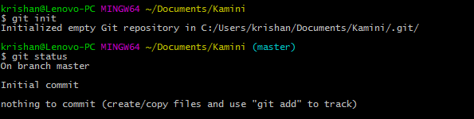

1. Add files to the repository

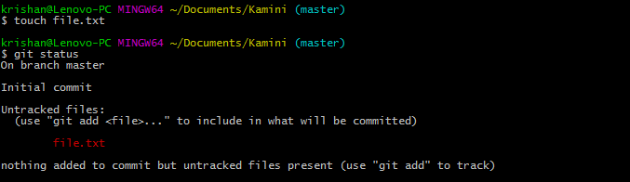

1. Unstage 1 file

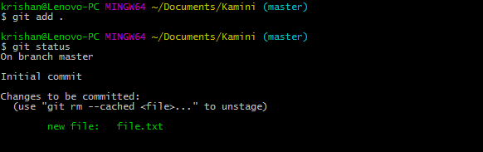

1. Commit the file

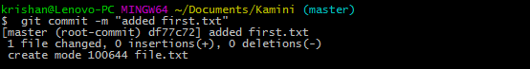

1. Add a remote

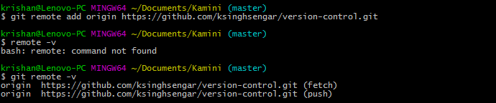

1. Undo changes to a particular file

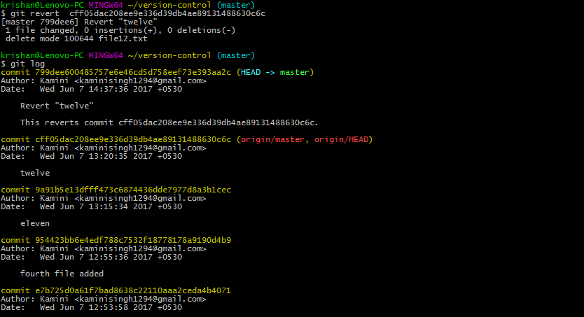

1. Push changes to Github

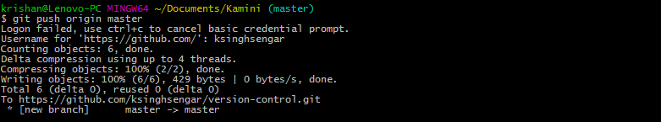

1. Clone the repository

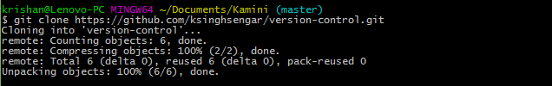

1. Add changes to one of the copies and pull the changesx in the other.

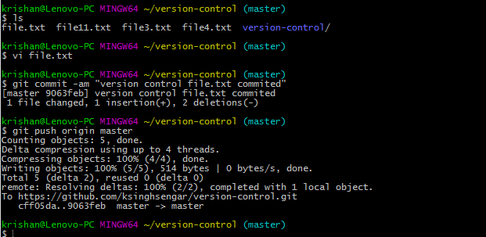

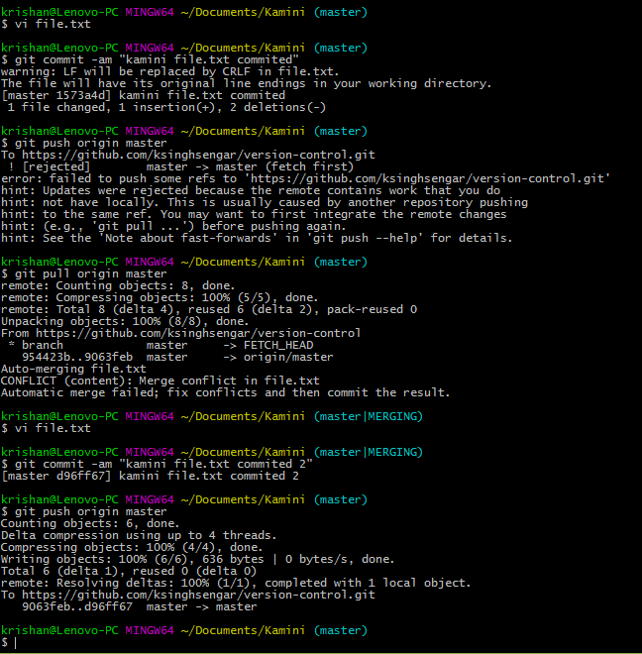

1. Check differences between a file and its staged version

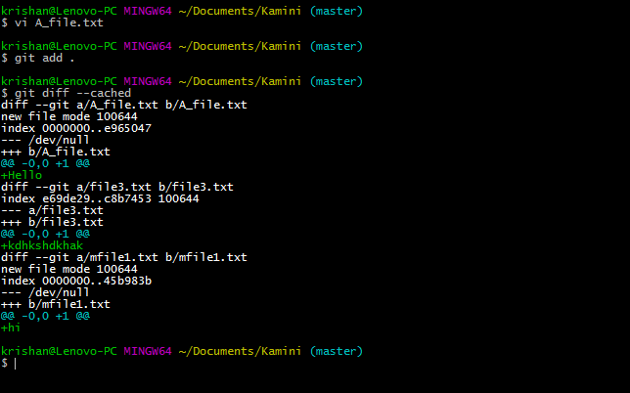

1. Ignore a few files to be checked in

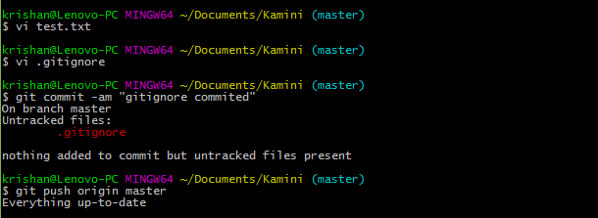

1. Create a new branch.

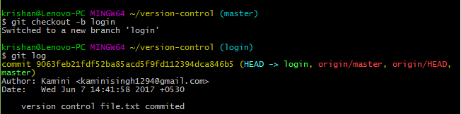

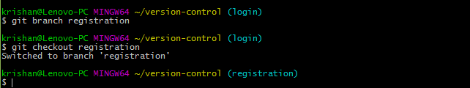

1. Diverge them with commits

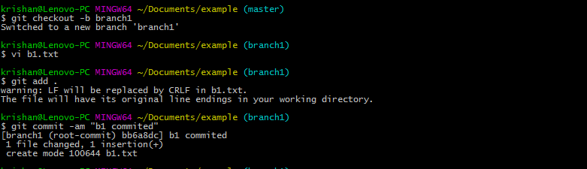

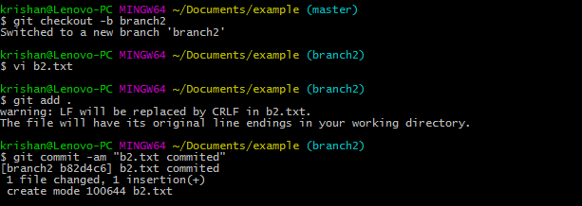

1. Edit the same file at the same line on both branches and commit

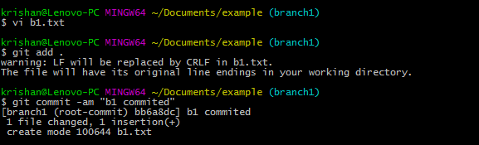

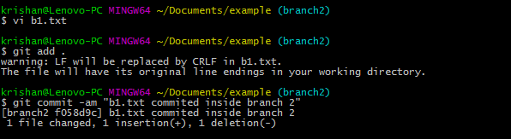

1. Try merging and resolve merge conflicts

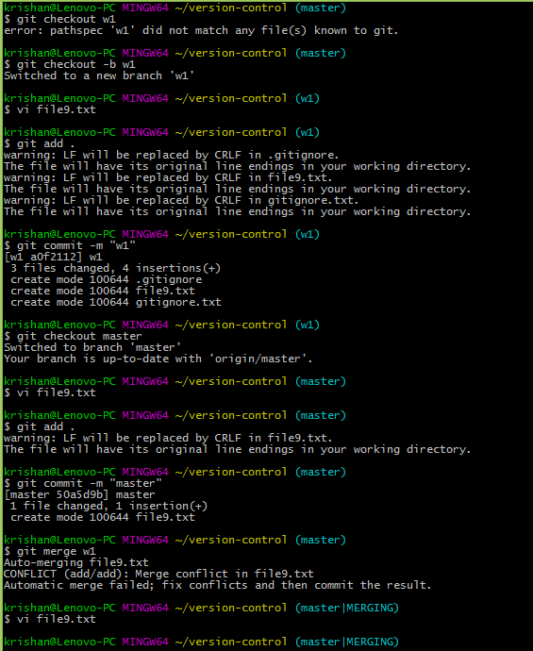

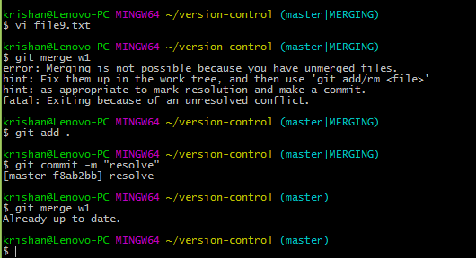

1. Stash the changes and pop them

